**南京大学本科生实验报告**

课程名称：**计算机网络** 任课教师：田臣/李文中 助教：

|  |  |  |  |
| --- | --- | --- | --- |
| 学院 | **计算机科学与技术系** | 专业（方向） | **计算机科学与技术** |
| 学号 | **191220154** | 姓名 | **张涵之** |
| Email | **1683762615@qq.com** | 开始/完成日期 | **2021/4/18** |

1. **实验名称：Lab 3: Respond to ARP**
2. **实验目的：**

Construct ARP reply and cache ARP table (upon receiving ARP request)

1. **实验内容**
   1. Task 2: Handle ARP Requests

Ready to make ARP work.

* 1. Task 3: Cached ARP Table

Maintain correlation between MAC address and corresponding IP address.

1. **实验结果**
   1. Task 2: Handle ARP Requests

Running the given switchyard test scenario.

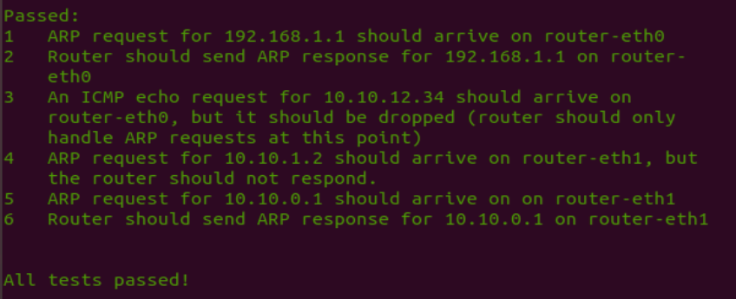

Testing my router in Mininet:

Ping the router from another host (server1).

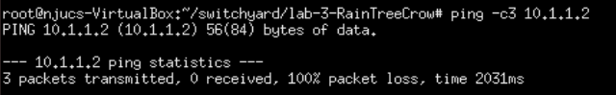

The router only replies to ARP request and drop all the other packets. 3 packets (ICMP ping requests?) are transmitted but none of them are “received”, server1 assume they are not received because the router does not reply.

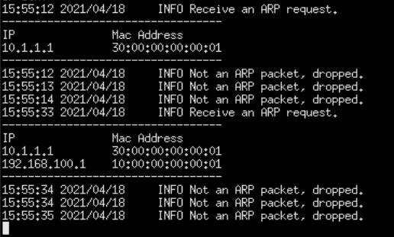

Here is what the router’s Mininet windows shows after it is pinged by the client and server1, each time the router receives an ARP request, an entry is added to the cache in Task 3, and it replies accordingly. The following 3 packets are not ARP packets and are dropped without further management.



Here are the packets captured by Wireshark, a Broadcast ARP, one private ARP and three ICMP Echo (ping) requests with “no response found”.

* 1. Task 3: Cached ARP Table

The cache table with switchyard tests are presented below

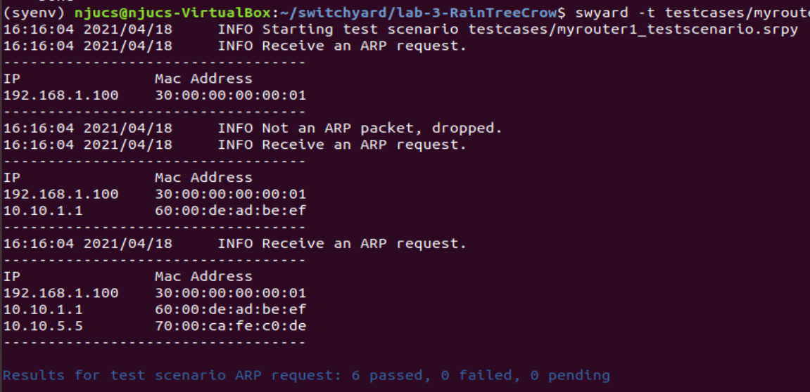

From the log info I can infer that the router received and processed three ARP requests and dropped one none ARP packet, which matches the tests.

1. **核心代码**
   1. Once you understood the logic, the code is very simple

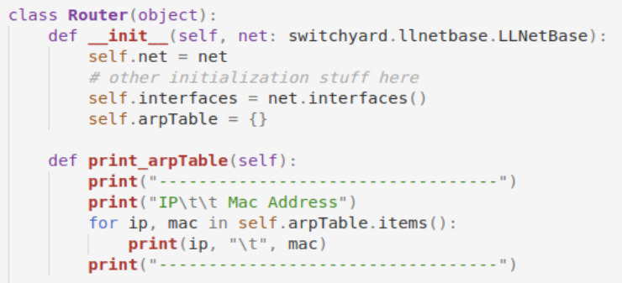

The ARP cache table is designed using a dictionary.



Here is how the cache table is printed.

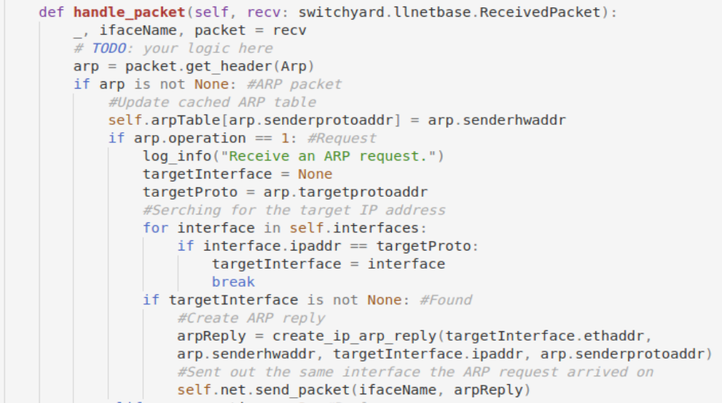

Here is how the ARP packet is handled. The sender’s IP and Mac addresses are added to the cache table. If the target protocol address can be found among the router’s interfaces’ IP address, the corresponding interface is used to create the ARP reply packet. The packet is then passed back to the sender, using the very same interface on which the ARP request arrived.

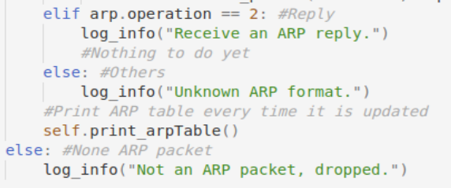

Certain other cases (ARP reply and non-ARP packets) are not dealt with in this lab. Log information are used to distinguish such cases, and the ARP table is printed every time the router receives and handles an ARP packet.

1. **总结与感想**
   1. When I used Wireshark to capture files in the first two labs, I always wondered what the packets meant, what those ARP and ICMP packets, those requests and replies stood for. Through the lectures and labs, I gradually begin to understand their logic and functions, and how the entire computer network operates.
   2. Dictionaries can be useful if used correctly.